Project Design Phase-II
Technology Stack (Architecture & Stack)

Date | 16 June 2026
Name | Mudit Manglik
Project Name | ShopEZ: E-Commerce Application

Technical Architecture:
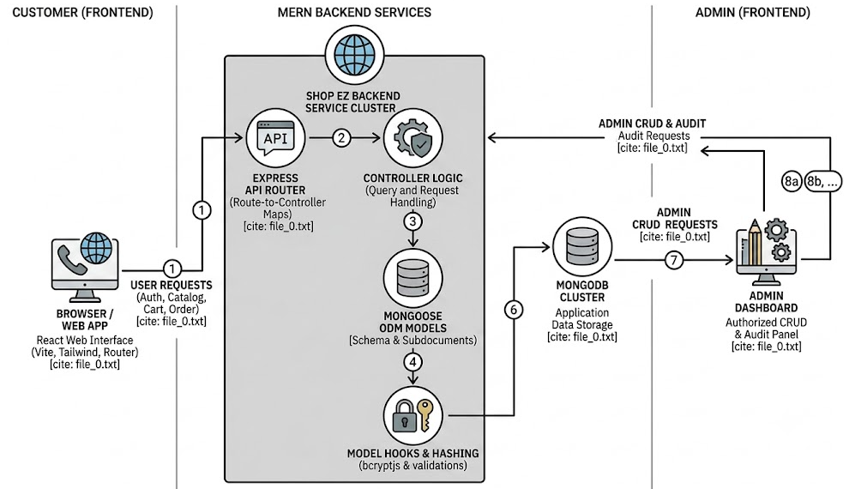

Table-1 : Components & Technologies:
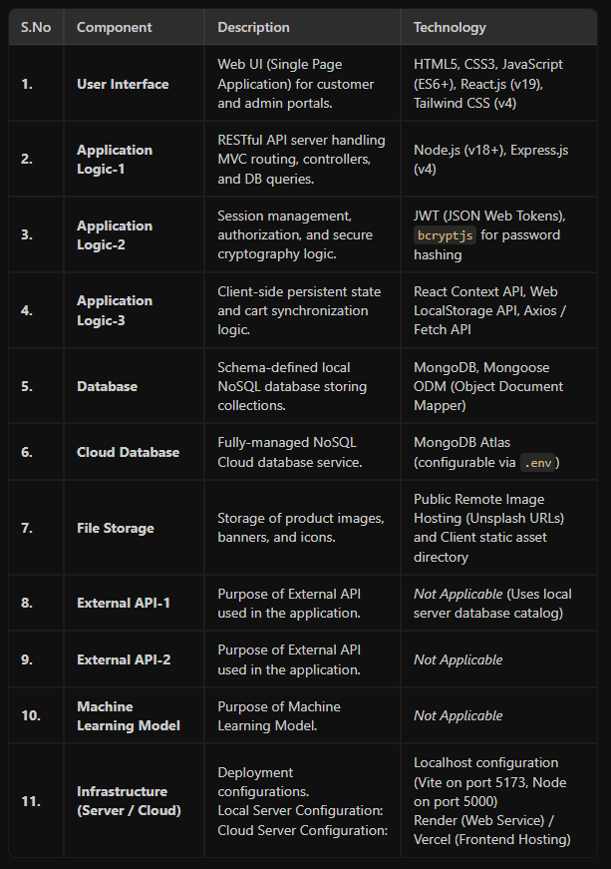

Table-2: Application Characteristics:
